FOR IMMEDIATE RELEASE
March 2012

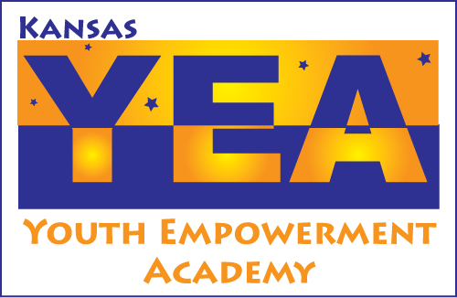
Contact: Johnna Godinez,
VISTA Fundraising Coordinator
Kansas Youth Empowerment Academy
PO Box 475
Topeka, KS 66601
866.577.5932 Toll Free
785.215.6698 TTY
785.215.6699 FAX
johnnag@kyea.org

RCIL and KYEA Join Together to Host Spring Fling
Event to include Garage Sale, Assistive Technology Fair, DME Drive, Food Stand, and more!

Topeka, Kan. -- The Kansas Youth Empowerment Academy (KYEA) and the Resource Center for Independent Living (RCIL) will join together to host a Spring Fling on Saturday, April 14, 2012. The Spring Fling will include the Annual Justin Cosco Fundraiser Garage Sale and Bake Sale, held by KYEA. RCIL will hold an Assistive Technology Resource Fair and a Durable Medical Equipment Drive. There will also be a voter registration booth, plant sale, and food stand.

The Spring Fling will take place from 8:00 AM to 1:00 PM and is open to all people. The event will be held in the parking lot in front of the KYEA and RCIL offices at 517 & 519 SW 37th Street, Topeka, KS. KYEA and RCIL are located in the Cedarwood office park, south of 37th St., between Topeka Boulevard and Kansas Avenue.

This is the third year that KYEA has held a fundraiser garage sale, but this year, they are joining up with RCIL to provide a fun, informational event for all! All proceeds from the garage sale will go towards the Justin Cosco Scholarship Award fund. The scholarship will be awarded to an alumnus of the Kansas Youth Leadership Forum (KSYLF) in June 2012. The award annually recognizes a young person with a disability who has demonstrated outstanding leadership skills in their community. The award will provide recognition and a registration for the recipient to attend the Kansas Disability Caucus in August of 2013.

RCIL will use the proceeds from the food sales for their Friend’s Consumer Group Christmas Party, and proceeds from the plant sale will be donated to the RCIL Build-A-Ramp program. Kansas Equipment Exchange will hold a durable medical good drive, and donations will be repaired to “like new status” and will be given to consumers in Kansas that are in need of durable medical goods.

The Kansas Youth Empowerment Academy is a grassroots nonprofit statewide agency which seeks to educate, mentor, and support youth with disabilities, ages 5-25, to be contributing members of their communities. The Resource Center for Independent Living is a non-profit organization that provides services to individuals with disabilities, their families and their communities. Their goal is to empower persons with disabilities to the maximum extent possible to control their lives and live independently within their respective communities served by RCIL.

For more information about the Spring Fling fund or the sale, contact Johnna Godinez, KYEA VISTA Fundraising Coordinator, at (785) 215-6655 or johnnag@kyea.org.

